**Assignment #1 – HTML Basics (Page Structure)**

**Student:** Usmanov Esanjon  
**Group:** SE-2406

**Objective**

By completing this assignment, I aimed to:

* Understand the structure and purpose of HTML.
* Use basic and intermediate HTML tags to create a simple webpage.
* Apply knowledge of text formatting, images, links, lists, tables, and forms.
* Publish my first webpage online.

**Step-by-Step Description of Tasks**

**Step 1. Basic HTML Setup & Two-Column Layout (Table Layout)**

* I created a new HTML file named index.html.
* Set the page title as **"My First Webpage"** inside the <title> tag.
* I began the code with a **table-based two-column layout**:
  + **Left column**: navigation menu (with links)
  + **Right column**: main content area

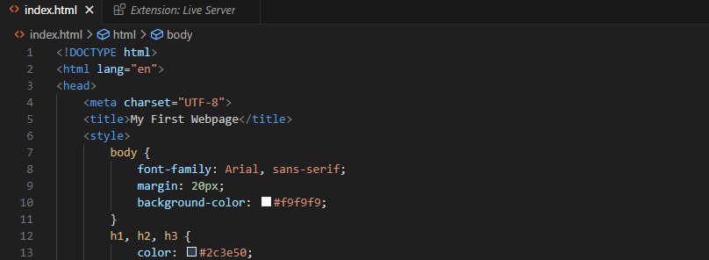

**Step 2. Headings and Paragraph**

* I added headings:
  + <h1> with my full name: **Usmanov Esanjon**
  + <h2> with my course: **SE-2406**
  + <h3> titled **"About Me"**

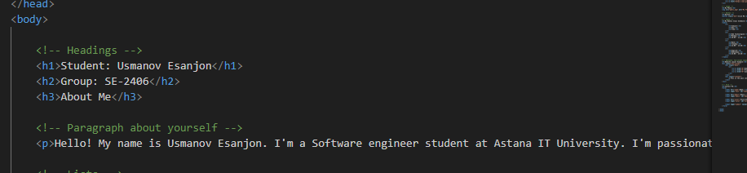

**🧩 Step 3. Lists**

* I created an **ordered list <ol>** of my hobbies.
* I created an **unordered list <ul>** of my favorite websites.

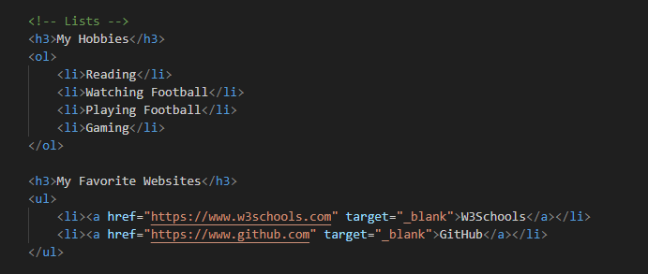

**🧩 Step 4. Image and Links**

* I inserted my photo using the <img> tag.  
  Example:
* <img src="myphoto.jpg" alt="My Photo">
* I added **two clickable links** using the <a> tag to favorite websites (e.g., GitHub, W3Schools).

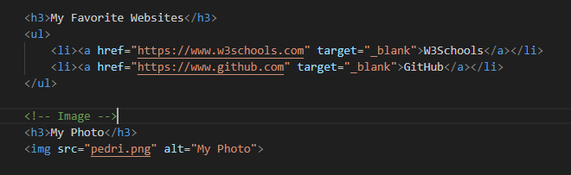

**🧩 Step 5. Button**

* I added a basic HTML button with the text **"Click Me"**.
* <button>Click Me</button>

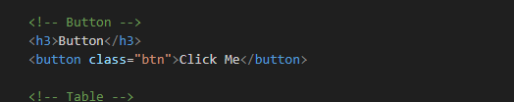

**🧩 Step 6. Weekly Schedule Table**

* I created a **table** with columns: **Subject**, **Day**, and **Time**
* I filled in a simple weekly schedule and expanded the table to show multiple subjects across different days.

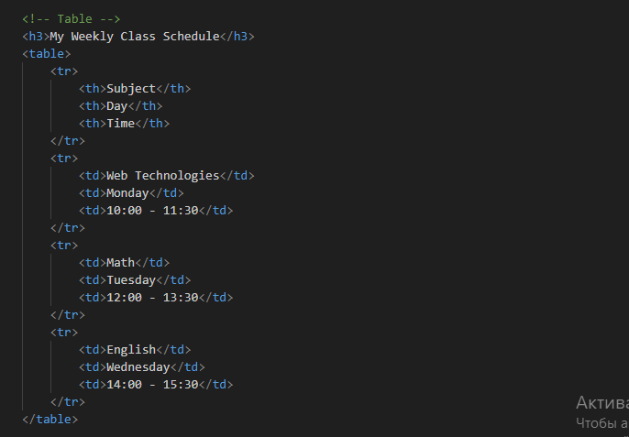

**🧩 Step 7. Two-Column Layout (Challenge)**

* I already mentioned that I **used a table for layout at the beginning** of the page, with:
  + Left column: a menu with links
  + Right column: the main content (headings, lists, paragraph, etc.)

**🧩 Step 8. Emojis**

* I added a paragraph describing my mood and included **three emojis** inside the text.

Example:

<p>I'm feeling great today!

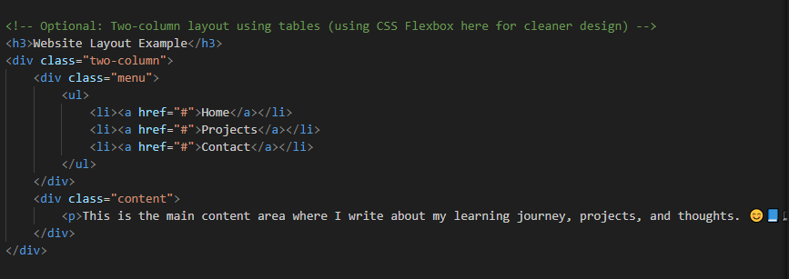

**🧩 Step 9. HTML Form**

I created a form using the following input fields:

* **Name:** text input
* **Email:** email input
* **Favorite Color:** color picker
* **Submit Button**

